How to Book property under E-Offer System.
Process flow:
- For doing booking under E-offer System consumer will be required to create his user id and password. For creating user id and password please follow the below mention steps:
  - If you are a new user click on Create profile
  - Fill up the details ask on the page for creating your user id and password
  - On the registration page you will required to select the option of property in which you are interested For example: Plot/Flat/House/ commercial. On the bases of your selection property will be shown to you under your login.
  - After creating your user id and password successfully you will receive the message both on Mobile and email.

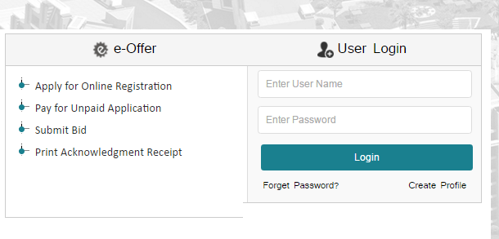

- Note: After submitting the details click on Submit button to create your user id and password. You will receive the message both on Mobile and email.
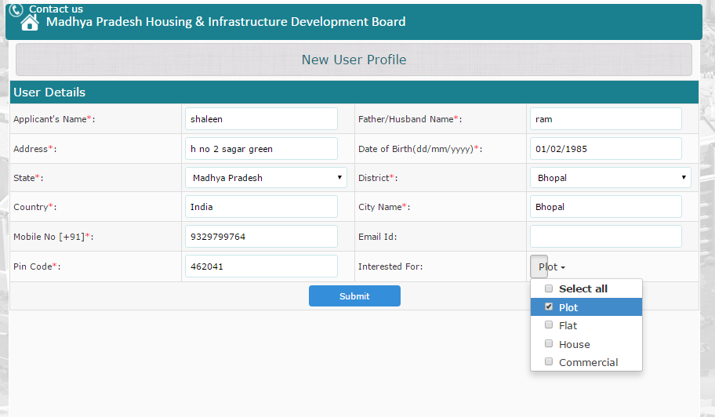

Note: In due course of time if you forget your password, we have give forget password option from where you can retrieve your password again.

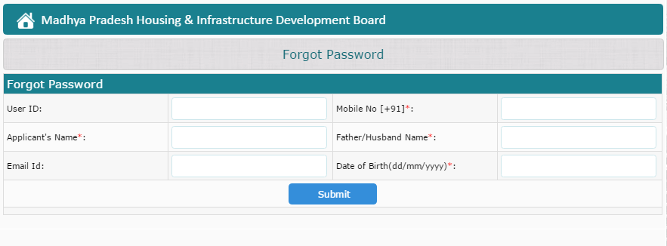

Note: For using all the options available on the screen mention below you will be required to login with user id and password.

- Apply for Online registration
- Submit Bid

- After creating your user id and password , Enter your user id and password received through SMS on your register mobile number / Email as shown in the below attach screen and click on login .
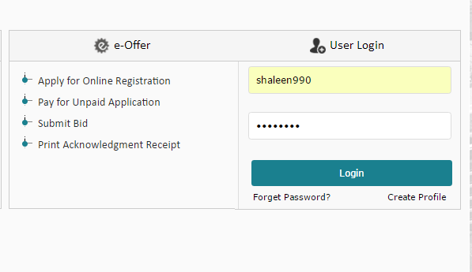

Note: As you login in you will be able to see the following information on the screen.
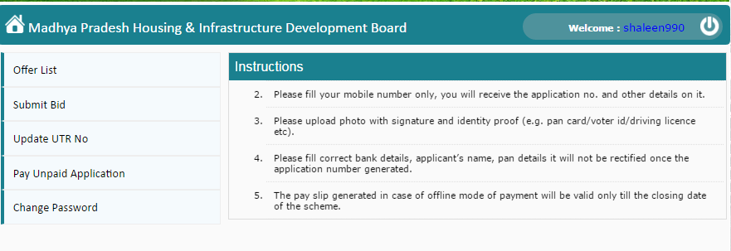

- Click on the offer list option to see various offers available. Applicant will be able to see all the property currently available under E-offers with the following details mention:
    - City wise
    - Budget wise
    - Type Commercial/Residential.
    - Built up area (Square meter)
    - Plot Area (Square meter)
    - Probable Cost (In Lakhs)
    - Registration Amount for each property mention available under E-offers.
    - Boucher
    - Floor plan
    - Location
    - Advertisements of property publish by the department.
    - Layout plan
    - Kiosk list of that particular city
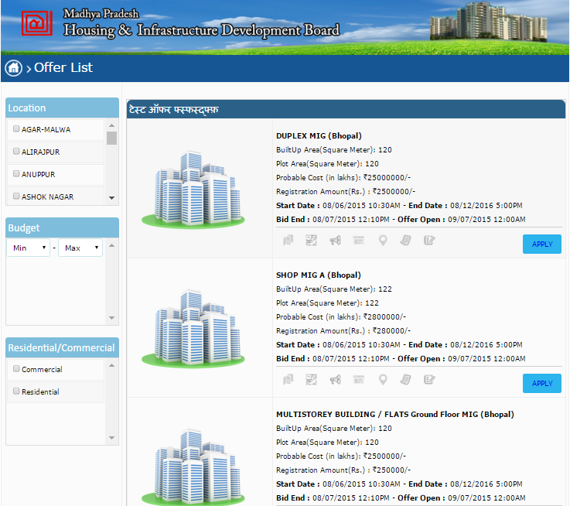
- After Selecting your Desired location where you want to purchase the property as per your budget click on “Apply”

- For Citizen Benefit we have created a link under which an applicant who have filled the application for any schemes before his data will be automatically updated back by providing the below mention details.
  - Steps:
    - Click on “Auto Fill form Data” Link
    - Than Enter your Mobile number and Get OTP on that Mobile number.
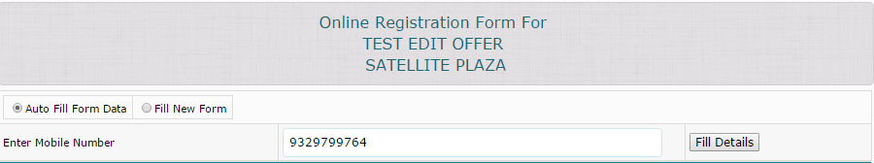

- If you are a new user than click on “Fill New Form link”.
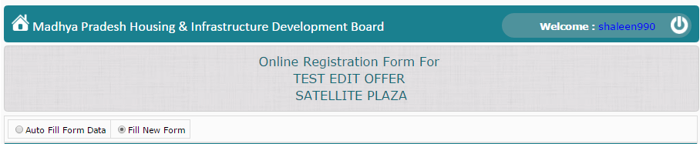

- As Shown below you will be required to fill the Application form.
Note: All the Heading mark with this sign * are mandatory field
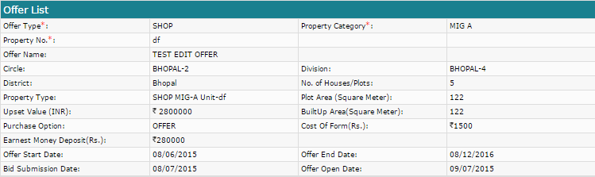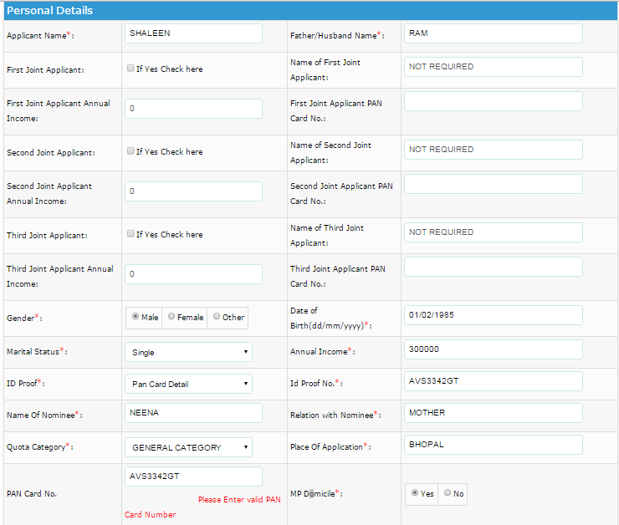
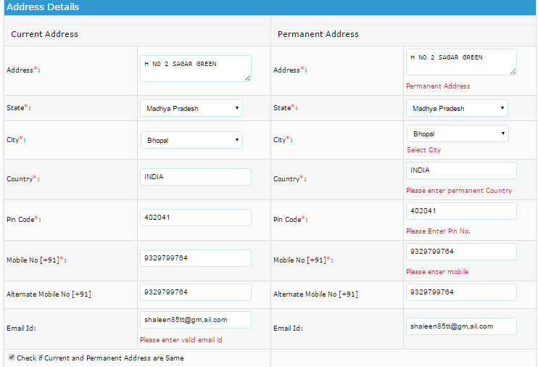
Note: For Customer Benefits and convinces we have section in the Application form for Reversing the amount of the customer if No property is been allotted to you this process will be done by the department.
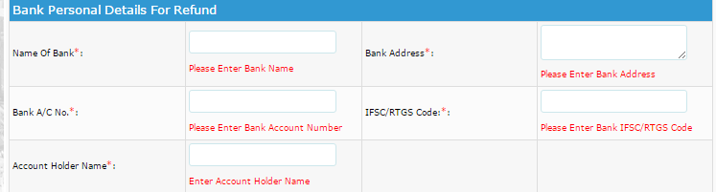
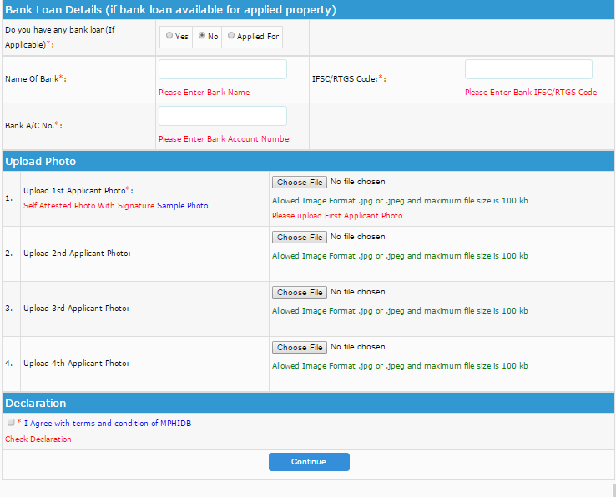

Specimen of a filled application under E-offer system
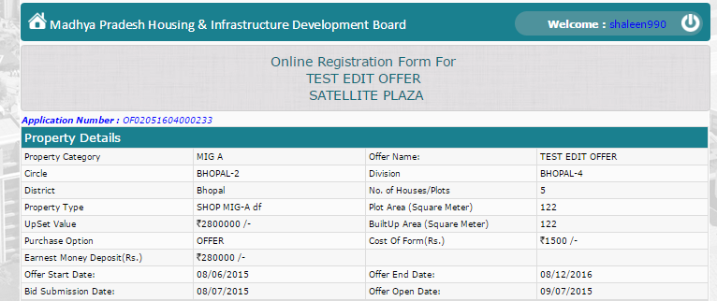
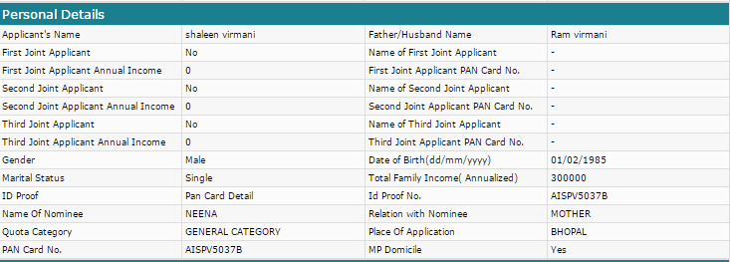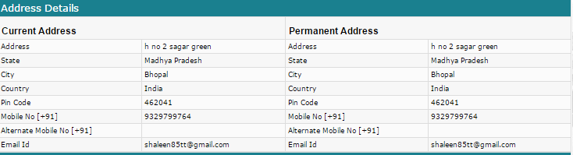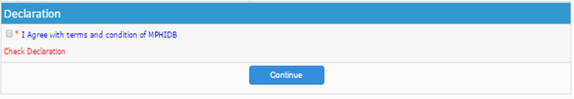 Note: After Clicking on Continue Colum you will be shown the below mention Page. Under the new System for the benefits of the Citizen we have Remove the Offline mode
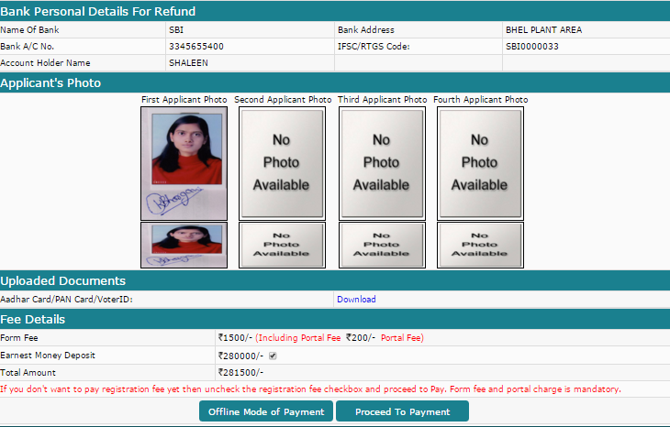
Proceed to payment
Note: As you click on Proceed to payment you will get the following Payment options available for making the payment.
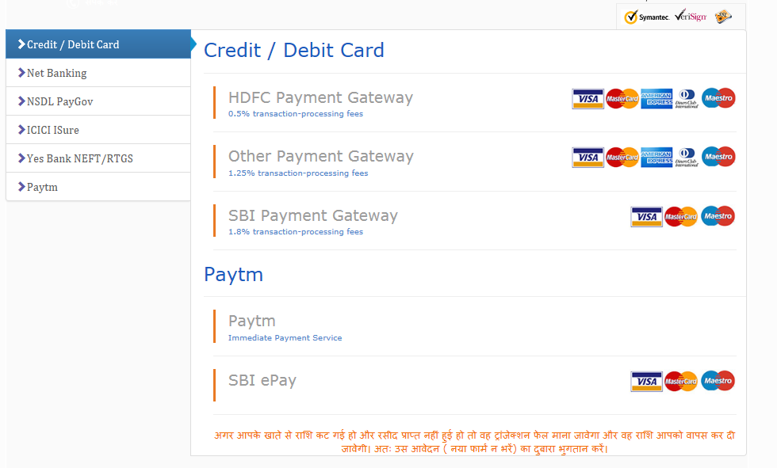
Note: If you do not have option of making online payment through your Credit card/ Debit Card/ Net banking, you can make the payment by depositing amount through E- Slip at any bank. And there will be no need of updating the UTR number after depositing the payment through E-Slip. For generating the E-Slip follow the below mention steps:
- Click on Yes Bank NEFT /RTGS link
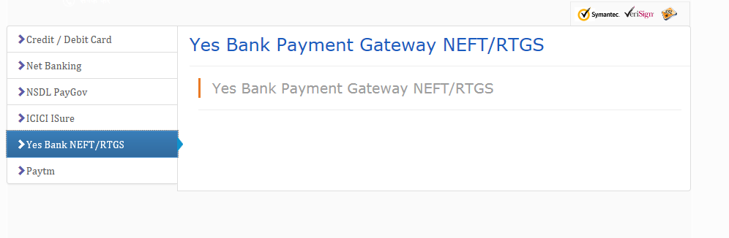

- As you click on the Yes bank payment Gateway NEFT/RTGS link, below show receipt will be generated take the print out of it and submit it at any bank of your choice.
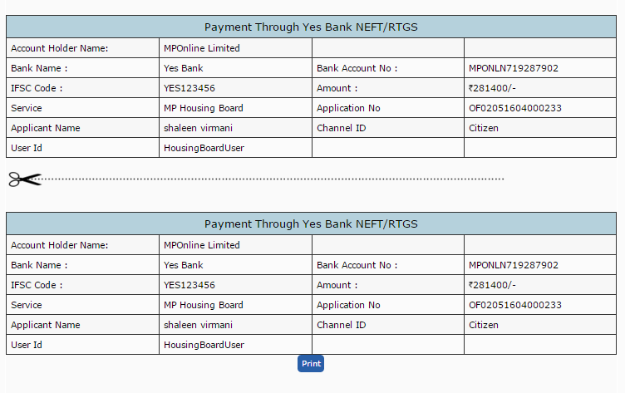
After submitting payment at bank your Application process will be complete and you will receive a message with details of Application number on your mobile number given in the Application form and Bid id, which you need to submit for confirming your process.
Note: If you’re NEFT/RTGS get failed at Bank than you will be required to Re-visit MPOnline portal for Re-Generating your new payment NEFT/RTGS slip and after that please process your payment with the new receipt.

For submitting bid:

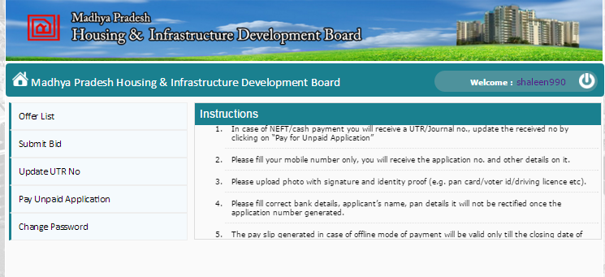
Click on the Submit bid option for Submitting Bid for your register property

Note: Enter your Application number and bid id received on your register mobile number and get OTP on your mobile number and Submit:

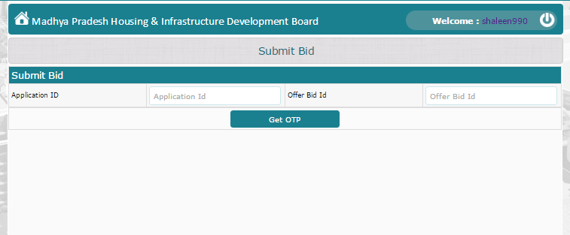
Submit
Enter the OTP received on your mobile in the box and click on Submit.

Note: As you click on Submit button a page will be open where you will be asked to submit your bid amount for the property you have done the registration, As you submit your bid your E-offer submission process for the selected property will be finished.

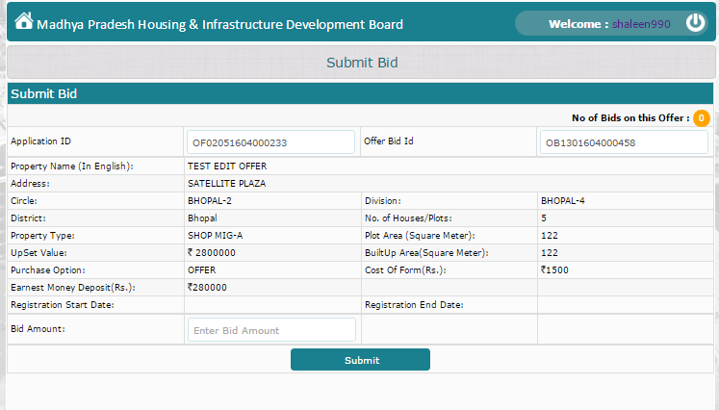
Enter Bid Amount and Click on Submit
Note: As you submit the bid you will get the following message and a message of successfully submission of the bid will be delivered on your register mobile number.
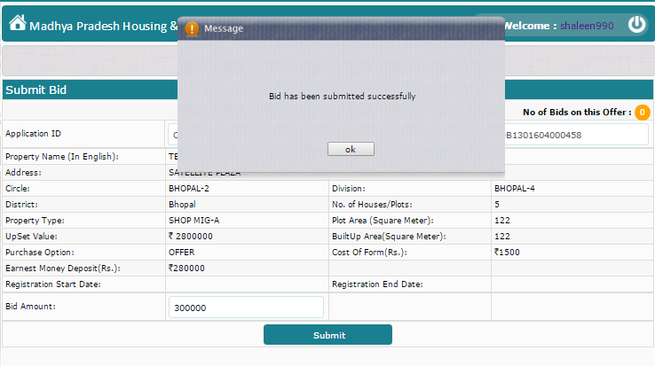

Process for getting your Registration amount refunded
Steps:
- Amount refund will be applicable only for those customers who have not got any property applied for.
- The amount will be transferred into the bank account mention by the customer in the application by the department.
- If you not get your amount refunded after Lottery is over you can contact on the numbers of the department available in the advertisement uploaded on MPOnline portal.
- If still you not get your amount refunded contact MPOnline with the below mention documents we will search your amount and if it is not been transferred to department due to any reason we will transfer the same or update you the status.
  - Documents :
    - Bank Statement showing amount transferred to MPOnline while applying for the schemes.
    - If Payment is been deposited through NEFT/RTGS using Yes bank payment gateway than copy of the receipt with seal & sign of bank on it.

